IBM Project Report

On

Emotion Detection From Facial Expression

### Developed By: -

Sarjan Patel (20162171019)

Dhyan Patel (20162101009)

Ujjval Patel (20162121021)

### Guided By:-

Dr. Rohit Patel (Internal)

Mr. Anoj Dixit (External)

**Submitted to**

**Department of Computer Science & Engineering Institute of Computer Technology**



**Year: 2024**



# CERTIFICATE

This is to certify that the IBM Project work entitled **“Emotion Detection From Facial Expression”** by Sarjan Patel (20162171019), Dhyan Patel (20162101009) and Ujjval Patel (20162121021) of Ganpat University, towards the partial fulfillment of requirements of the degree of Bachelor of Technology – Computer Science and Engineering, carried out by them in the CSE(BDA/CS/CBA) Department at ICT The results/findings contained in this Project have not been submitted in part or full to any other University / Institute for award of any other Degree/Diploma.

**Name & Signature of Internal Guide**

**Name & Signature of Head**

**Place: ICT - GUNI**

### Date:

**ACKNOWLEDGEMENT**

An Industry Internship project is a golden opportunity for learning and self-development. I consider myself very lucky and honored to have so many wonderful people lead me through in completion of this project. First and foremost, I would like to thank Dr. Rohit Patel, Principal, ICT and Prof. Dharmesh Darji, Head, ICT who allowed us to undertake this project. My thanks to Dr. Rohit Patel & Mr. Anoj Dixit for their guidance in project work, who despite being extraordinarily busy with academics, took time out to hear, guide, and keep us on the correct path. We do not know where we would have been without his help. The CSE department monitored our progress and arranged all facilities to make life easier. We choose this moment to acknowledge their contribution gratefully.

### SARJAN PATEL (ENROLLMENT NO. 20162171019)

### DHYAN PATEL (ENROLLMENT NO. 20162101009)

### UJJVAL PATEL (ENROLLMENT NO. 20162121021)

**ABSTRACT**

This project employs artificial intelligence and machine learning methods to detect human emotions from facial expressions. By training convolutional neural networks on a diverse dataset of annotated facial images, the system achieves high accuracy in recognizing emotions such as happiness, sadness, anger, and more. Transfer learning from pre-trained models enhances performance, while real-time emotion detection is demonstrated through integration with webcam or video inputs. The system's effectiveness is evaluated on benchmark datasets, showcasing its state-of-the-art performance in emotion recognition tasks. This research contributes to the advancement of affective computing, providing an efficient and accurate solution for automated human emotion recognition from facial expressions, with potential applications in various domains including human-computer interaction, psychology, and healthcare.

**LIST OF FIGURES**

| Figure 2.2.1 Flow of Working of Model | 06 |
| --- | --- |
| Figure 2.3.1 Densenet201 Architecture | 06 |
| Figure 2.4.1 VGG16 Architecture | 07 |
| Figure 2.5.1 VGG19 Architecture | 08 |
| Figure 4.1 Face Expression Recognition Dataset | 12 |
| Figure 5.1 Flowchart of the project | 14 |
| Figure 7.1 Testing Process | 21 |
| Figure 7.2 Accuracy and Loss of Model | 22 |

**LIST OF TABLES**

| Table 3.1 Software Requirements | 10 |
| --- | --- |
| Table 3.2 Hardware Requirements | 10 |
| Table 7.2.1 Comparison of different model accuracy | 23 |

**TABLE OF CONTENTS**

| **Chapter** | **Content** | | | | **Page No.** |
| --- | --- | --- | --- | --- | --- |
| **1.** | **Introduction** | | | | 01 |
|  | 1.1 | Background and motivation | | | 02 |
|  | 1.2 | Objectives of the project | | | 02 |
|  | 1.3 | Scope | | | 02 |
| **2.** | **Literature Review** | | | | 03 |
|  | 2.1 | Review of existing literature on emotion detection | | | 04 |
|  | 2.2 | Overview of CNN models used in emotion recognition | | | 04 |
|  | 2.3 | Overview of Densenet201 models used in emotion recognition | | | 05 |
|  | 2.4 | Overview of VGG16 models used in emotion recognition | | | 06 |
|  | 2.5 | Overview of VGG19 models used in emotion recognition | | | 06 |
|  | 2.6 | Discussion of related works and their methodologies | | | 07 |
| **3.** | **Software and Hardware Requirements** | | | | 08 |
|  | 3.1 | Software Requirements | | | 09 |
|  | 3.2 | Hardware Requirements | | | 09 |
| **4.** | **Dataset Description** | | | | 10 |
|  | 4.1 | Description of the dataset used for training and testing | | | 11 |
| **5.** | **Methodology** | | | | 12 |
|  | 5.1 | Project Flowchart | | | 13 |
|  | 5.2 | Technologies Used | | | 14 |
|  | 5.3 | Overview of the CNN architecture used | | | 14 |
|  | 5.4 | Details of model training process | | | 14 |
|  | 5.5 | Hyperparameters used in training | | | 15 |
| **6.** | **Modules** | | | | 16 |
|  | 6.1 | Login Module | | | 17 |
|  | 6.2 | Sign-up Module | | | 17 |
|  | 6.3 | Dashboard - Live Face Detection Interface | | | 17 |
|  | 6.4 | Report Module | | | 17 |
|  | 6.5 | User Profile | | | 17 |
|  | 6.6 | Admin Module | | | 17 |
| **7.** | **Results** | | | | 19 |
|  | 7.1 | Testing Process | | | 20 |
|  | 7.2 | Evaluation Metrics | | | 21 |
|  | 7.3 | Comparison of different Model accuracy | | | 22 |
| **8.** | **Screenshots** | | | | 23 |
|  | **Conclusion** | | | | 31 |
|  | **References** | | | | 33 |
|  | **Plagiarism Report** | | | | 35 |

**CHAPTER: 1 INTRODUCTION**

**CHAPTER 1 INTRODUCTION**

**1.1 Background and motivation**

* Emotion detection has significant applications in understanding human behavior and enhancing user experiences in various domains.
* The project is motivated by the growing demand for intelligent systems capable of understanding and responding to human emotions, particularly in fields like virtual reality, gaming, customer service, and mental health.
* The ability to accurately detect emotions from facial expressions can lead to improved human-computer interactions, personalized content recommendations, targeted advertising, and emotion-aware applications.

**1.2 Objectives of the project**

* The main objective of the project is to develop an emotion detection system using Convolutional Neural Networks (CNNs) and deep learning techniques.The system should be able to accurately recognize and classify emotions such as happiness, sadness, anger, surprise, disgust, fear, and neutral expressions from facial images.The project aims to provide a robust and reliable tool for real-time emotion analysis, which can be used in various applications such as human-computer interaction, healthcare, marketing, and entertainment.

**1.3 Scope**

* **Data Collection:** The project will involve collecting a diverse dataset of facial images representing different emotions. This dataset will be used for training, validation, and testing purposes.
* **Preprocessing:** Image preprocessing techniques such as normalization, resizing, and augmentation will be applied to prepare the data for training the CNN model.
* **Model Development:** A CNN architecture will be designed and implemented using TensorFlow/Keras to learn features from facial images and classify emotions.
* **Training and Evaluation:** The model will be trained on the collected dataset and evaluated using metrics such as accuracy, precision, recall, and F1 score to assess its performance.
* **Real-time Emotion Detection:** Once trained and validated, the model will be integrated into a real-time system capable of detecting emotions from live video streams or static images.

**CHAPTER: 2 LITERATURE OVERVIEW**

### CHAPTER 2 LITERATURE OVERVIEW

**2.1 Review of existing literature on emotion detection**

Several studies have explored various techniques for emotion detection from facial expressions. Early approaches primarily relied on handcrafted features and machine learning algorithms. However, with the advent of deep learning, Convolutional Neural Networks (CNNs) have emerged as the state-of-the-art method for facial emotion recognition. These CNN-based models leverage hierarchical feature learning to automatically extract discriminative features from facial images, leading to improved performance in emotion classification tasks.

**2.2 Overview of CNN models used in emotion recognition**

CNNs are widely used in emotion recognition due to their ability to learn spatial hierarchies of features from images. They typically consist of convolutional layers for feature extraction followed by fully connected layers for classification. In emotion recognition tasks, CNNs are trained on labeled facial expression datasets to detect and classify emotions such as happiness, sadness, anger, fear, disgust, surprise, and neutral expressions. Popular CNN architectures for emotion recognition include the use of convolutional layers with batch normalization, activation functions like ReLU, and pooling layers for spatial downsampling. Transfer learning with pre-trained CNN models, such as ResNet, Inception, and MobileNet, is also common to improve performance with limited training data.

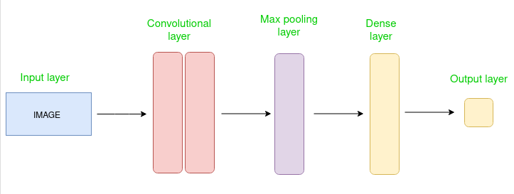

### CHAPTER 2 LITERATURE OVERVIEW

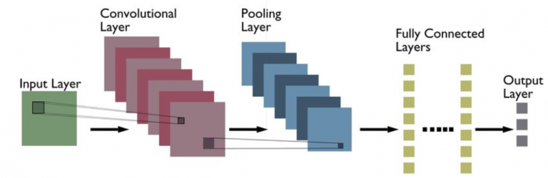

*Figure 2.2.1 Flow of Working of Model*

**2.3 Overview of Densenet201 model used in emotion recognition**

Densenet201 is a deep CNN architecture known for its densely connected layers, which promote feature reuse and gradient flow throughout the network. In emotion recognition, Densenet201 has shown promising results by capturing intricate facial features essential for accurate emotion classification. Its dense connectivity pattern facilitates feature propagation and helps in learning complex patterns from facial expressions. Densenet201 models are often fine-tuned on emotion-specific datasets or used as feature extractors in conjunction with other classifiers like Support Vector Machines (SVMs) or fully connected layers for emotion recognition tasks.

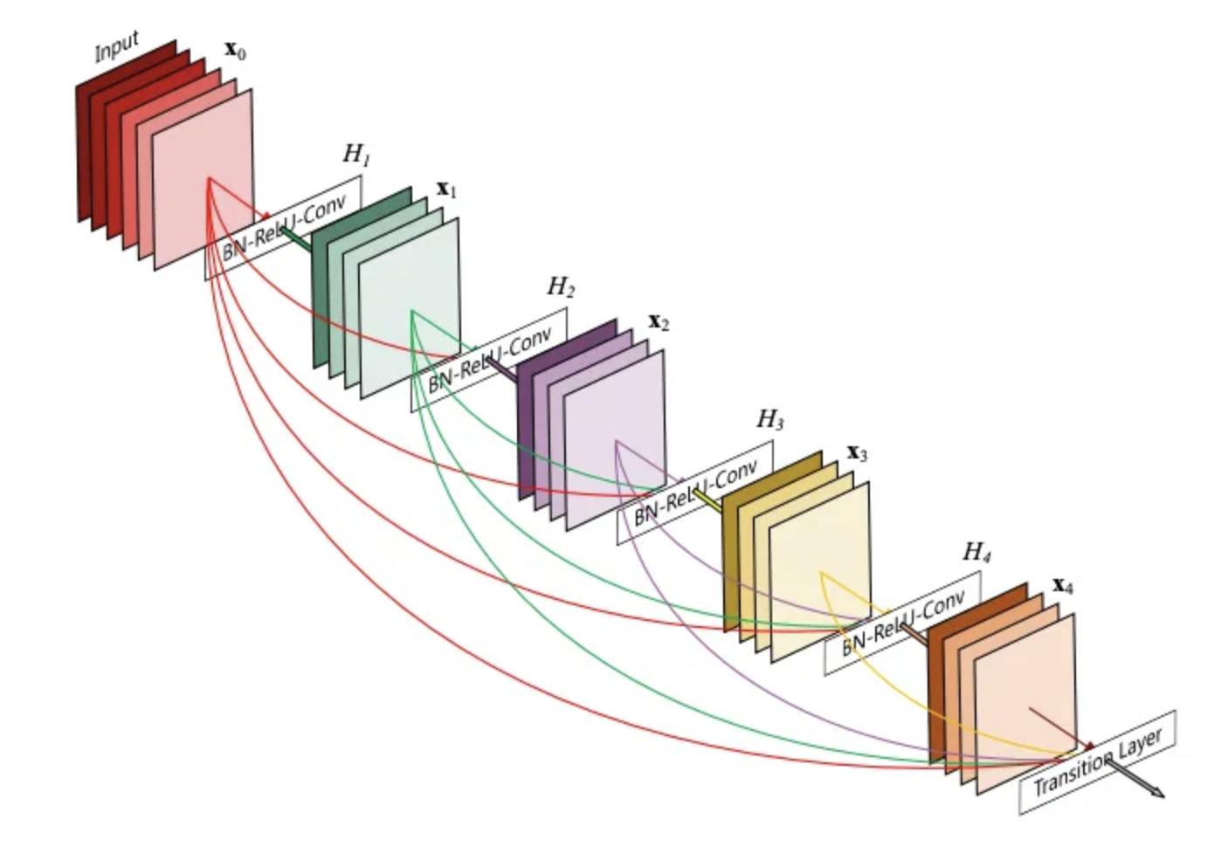

*Figure 2.3.1 Densenet201 Architecture*

### CHAPTER 2 LITERATURE OVERVIEW

**2.4 Overview of VGG16 model used in emotion recognition**

VGG16 is a deep CNN architecture known for its simplicity and effectiveness in image classification tasks. It consists of multiple convolutional layers followed by fully connected layers and uses small 3x3 convolutional filters with max-pooling layers for feature extraction and spatial downsampling. In emotion recognition, VGG16 models can capture basic to intermediate facial features and spatial information relevant to emotions. While not as deep as some newer architectures, VGG16's straightforward design and proven performance make it a reliable choice for emotion classification tasks.

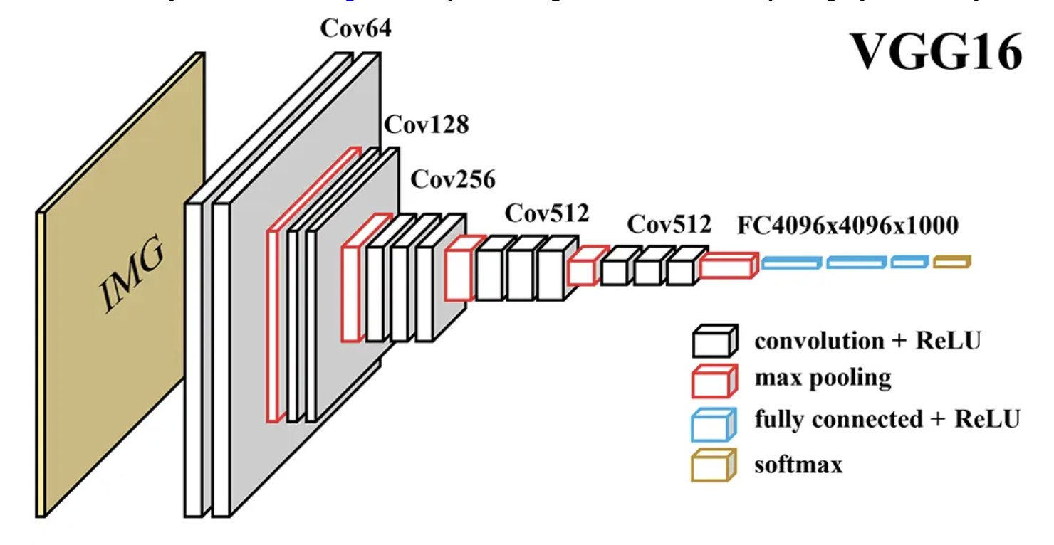

*Figure 2.4.1 VGG16 Architecture*

**2.5 Overview of VGG19 model used in emotion recognition**

VGG19 is an extension of VGG16 with additional convolutional layers, offering a deeper architecture for more complex feature learning. It maintains the same basic structure of convolutional and pooling layers but with increased depth, allowing for better representation of intricate patterns in images. In emotion recognition, VGG19 models excel at capturing fine-grained details and variations in facial expressions, leading to enhanced emotion classification accuracy. Despite its increased complexity compared to VGG16, VGG19's architecture remains relatively straightforward, making it practical for emotion recognition applications where detailed feature extraction is crucial.

### CHAPTER 2 LITERATURE OVERVIEW

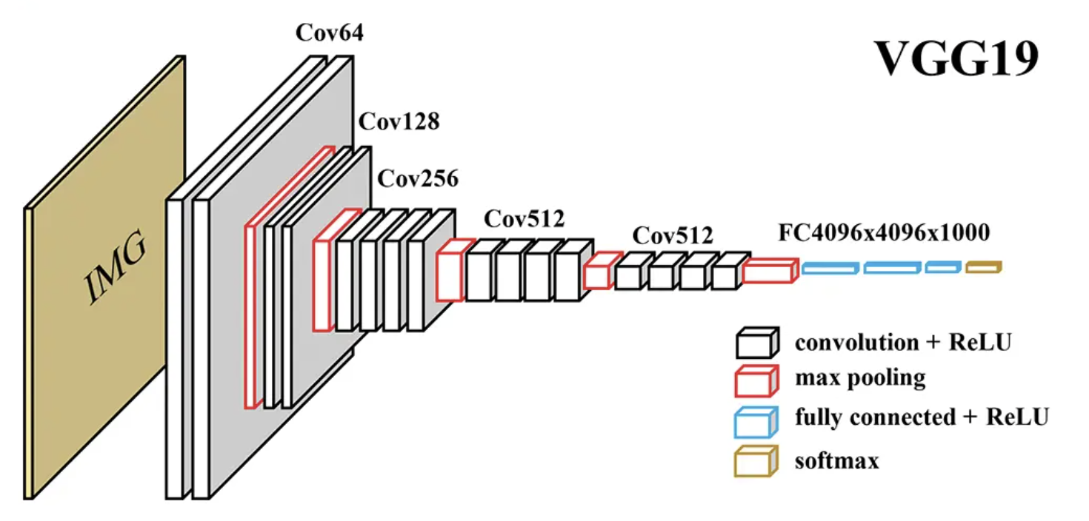

*Figure 2.5.1 VGG19 Architecture*

**2.6 Discussion of related works and their methodologies**

Previous studies have employed diverse methodologies for emotion detection, including dataset collection, preprocessing techniques, model architectures, and evaluation metrics. Some research focuses on improving the robustness of emotion recognition models to variations in facial expressions, illumination, and pose, while others explore multimodal approaches combining facial cues with audio or text data for enhanced emotion understanding.

# CHAPTER: 3 SOFTWARE AND HARDWARE REQUIREMENTS

### CHAPTER 3 SOFTWARE AND HARDWARE REQUIREMENTS

**3.1 Software Requirements**

The software requirements for the project are as follows:

| **Operating System** | OS With Browser Connectivity |
| --- | --- |
| **Other Tools** | Internet Browser |

*Figure 3.1 Software Requirements*

**3.2 Hardware Requirements**

Following are the hardware requirements for the project:

| **Processor** | 2.0 GHz |
| --- | --- |
| **RAM** | 4 GB |
| **HDD** | 100 GB |

*Figure 3.2 Hardware Requirements*

**CHAPTER: 4 DATASET DESCRIPTION**

### CHAPTER 4 DATASET DESCRIPTION

**4.1 Description of the dataset used for training and testing**

The dataset utilized for training and testing the emotion detection model is the Face expression recognition dataset. It consists of over 28,800 labeled images of facial expressions annotated with one of seven emotions: neutral, happiness, sadness, surprise, anger, disgust, and fear. The dataset is divided into training, validation, and test sets, with the majority of images depicting frontal faces with varying degrees of intensity in expressions.

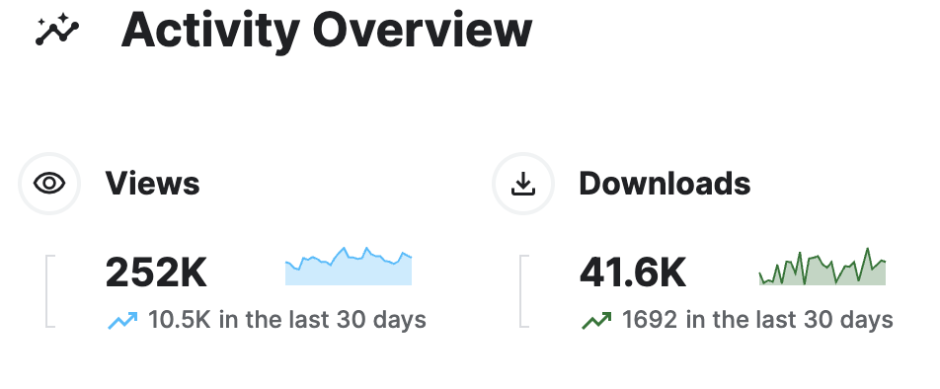

*Figure 4.1 Face Expression Recognition Dataset*

## 

## 

## 

## 

## 

## 

## 

## 

## 

## 

## 

## 

## 

## 

## 

## 

## 

## 

## 

## 

## 

## 

## 

## 

## 

## 

## CHAPTER: 5 METHODOLOGY

### CHAPTER 5 METHODOLOGY

### Project Flowchart

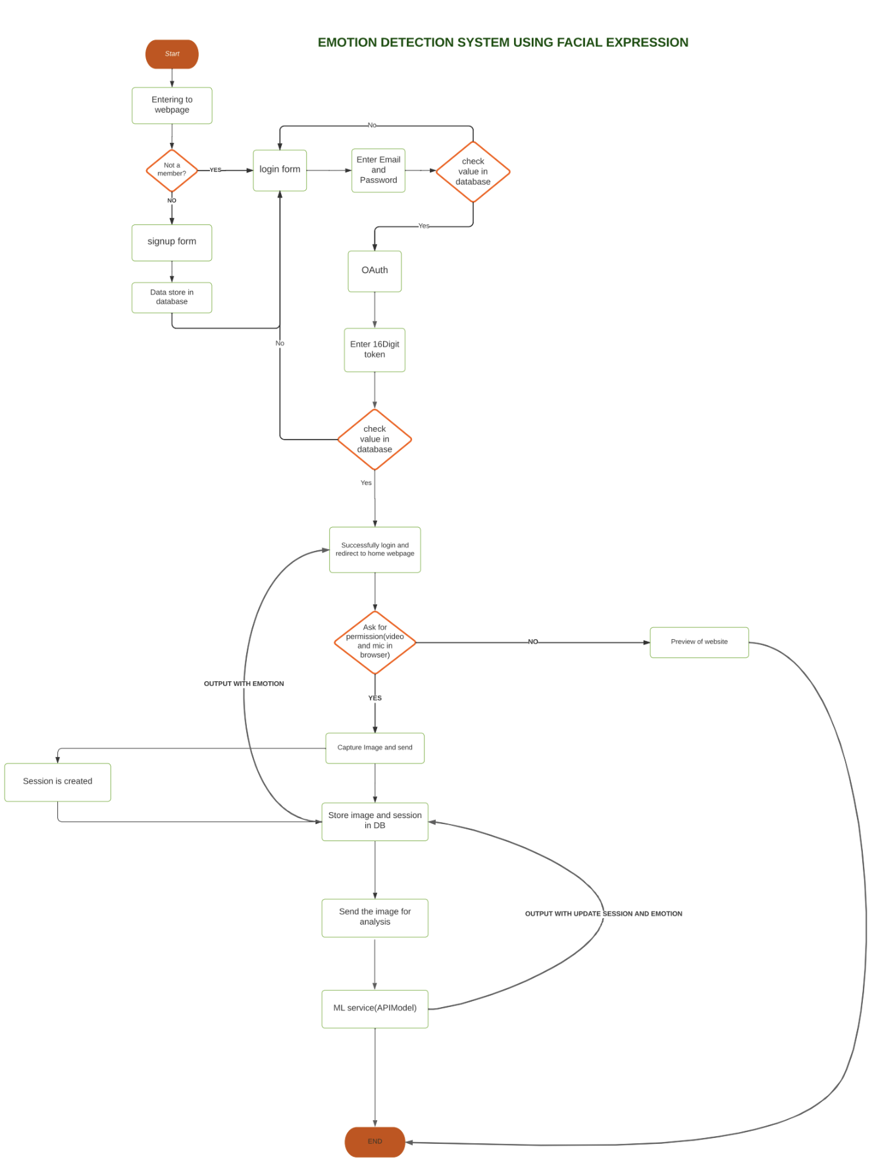

*Figure 5.1 Flowchart of the project*

### CHAPTER 5 METHODOLOGY

### The emotion detection system begins with the user signing up and logging into the application. Upon successful authentication, the system requests permission to access the user's camera. Once granted, the system activates the camera to capture an image of the user's face. This captured image is then processed using face detection algorithms to locate the facial features and extract the relevant facial expression data. The extracted data is then passed through a pre-trained machine learning model, such as a Convolutional Neural Network (CNN) or MobileNet, trained specifically for emotion recognition tasks. The model analyzes the facial expression data and predicts the emotions present in the captured image. Finally, the system displays the predicted emotions along with their corresponding percentages or confidence scores to the user, providing real-time feedback on the detected emotions.

### Technologies used

* **Programming Languages**: Python, Django, React.js
* **Libraries:** Python 3, OpenCV, TensorFlow
* **Datasets:** Kaggle, Github
* **Cloud-based Solutions (optional):** Versel, Render, Neon.tech

### Overview of the CNN architecture used

The CNN architecture used for facial emotion recognition is based on a modified version of the VGG (Visual Geometry Group) network. The VGG model consists of multiple convolutional layers with small 3x3 filters followed by max-pooling layers for spatial downsampling. The final layers include fully connected layers and a softmax classifier for emotion classification.

* 1. **Details of model training process**

The model training process involves several key steps:

* **Data Preprocessing:** Images are resized, normalized, and augmented to enhance the diversity of the training dataset.
* **Model Compilation:** The CNN model is compiled with appropriate loss function (e.g., categorical cross-entropy) and optimizer (e.g., Adam optimizer).
* **Model Training:** The model is trained on the training dataset using backpropagation and gradient descent, optimizing the chosen loss function.

### CHAPTER 5 METHODOLOGY

* **Model Evaluation:** The trained model is evaluated on the validation dataset to monitor performance metrics such as accuracy and loss.
* **Fine-tuning:** Hyperparameters are adjusted, and model architecture is fine-tuned based on validation performance to improve generalization
  1. **Hyperparameters used in training**

The hyperparameters used in training the CNN model include:

* **Learning Rate:** 0.001
* **Batch Size:** 32-128
* **Number of Epochs: 20-**70
* **Optimizer:** Adam optimizer
* **Loss Function:** Categorical Cross-Entropy

# 

# CHAPTER: 6 MODULES

### CHAPTER 6 MODULES

**6.1 Login Module**

**6.2 Sign-up Module**

**6.3 Dashboard - Live Face Detection Interface**

* **Description:** Design an intuitive and user-friendly interface to display the live video feed along with the detected emotions. Include visual indicators or text labels to communicate the recognized emotions effectively to the user.
* Optimize the code for real-time processing to ensure smooth operation and low latency in displaying the live video feed and detected emotions. Utilize multi-threading or parallel processing techniques to improve computational efficiency

**6.4 Report Module**

* **Description**: The analytics page will exhibit all emotions identified by the machine learning model along with their respective percentages, showcasing a comprehensive overview of emotional content.

**6.5 User Profile**

* **User Information:** Display the user's name, profile picture, and any other relevant information.
* **Emotion Detection Results:** Show the results of recent emotion detection analyses, such as detected emotions (e.g., happiness, sadness, anger) and their corresponding percentages.
* **Emotion History:** Provide a history of past emotion detection results, possibly in a timeline or list format, showing trends or changes in emotions over time.
* **Settings and Preferences:** Allow users to customize settings related to emotion detection, such as choosing specific emotions to track, adjusting notification preferences, or changing analysis intervals.

**6.6 Admin Module**

* The content on an admin page for emotion detection typically includes features and functionalities related to managing the emotion detection system. Here are some common elements you might find on an admin page for emotion detection.

### CHAPTER 6 MODULES

* **Dashboard Overview:** A summary of the system's performance, including metrics such as accuracy, precision, recall, and F1 score. It may also include charts or graphs to visualize trends and performance over time.
* **Manage Users:** Functionality to add, edit, or delete. This could include adding new emotions, updating the labels or descriptions of existing emotions, and removing obsolete emotions.

**CHAPTER: 7 RESULTS**

### CHAPTER 7 RESULTS

**7.1 Testing Process**

The process begins by loading the trained model, whether it be VGG16, DenseNet, or CNN. Subsequently, a new image is supplied as input. Upon receiving the image, the model proceeds to classify it and subsequently presents the classification results.

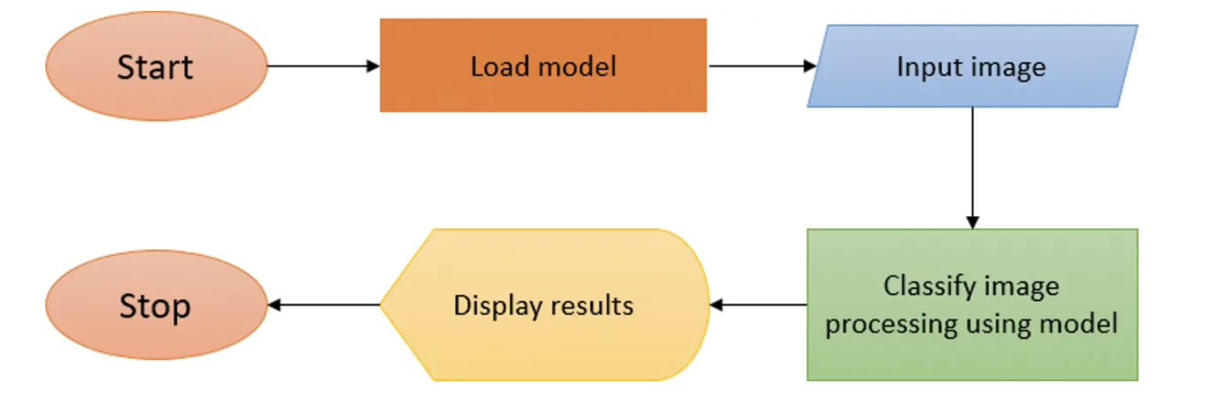

*Figure 7.1 Testing Process*

### CHAPTER 7 RESULTS

**7.2 Evaluation metrics**

The training accuracy is around 84% and the validation accuracy is around 64%.

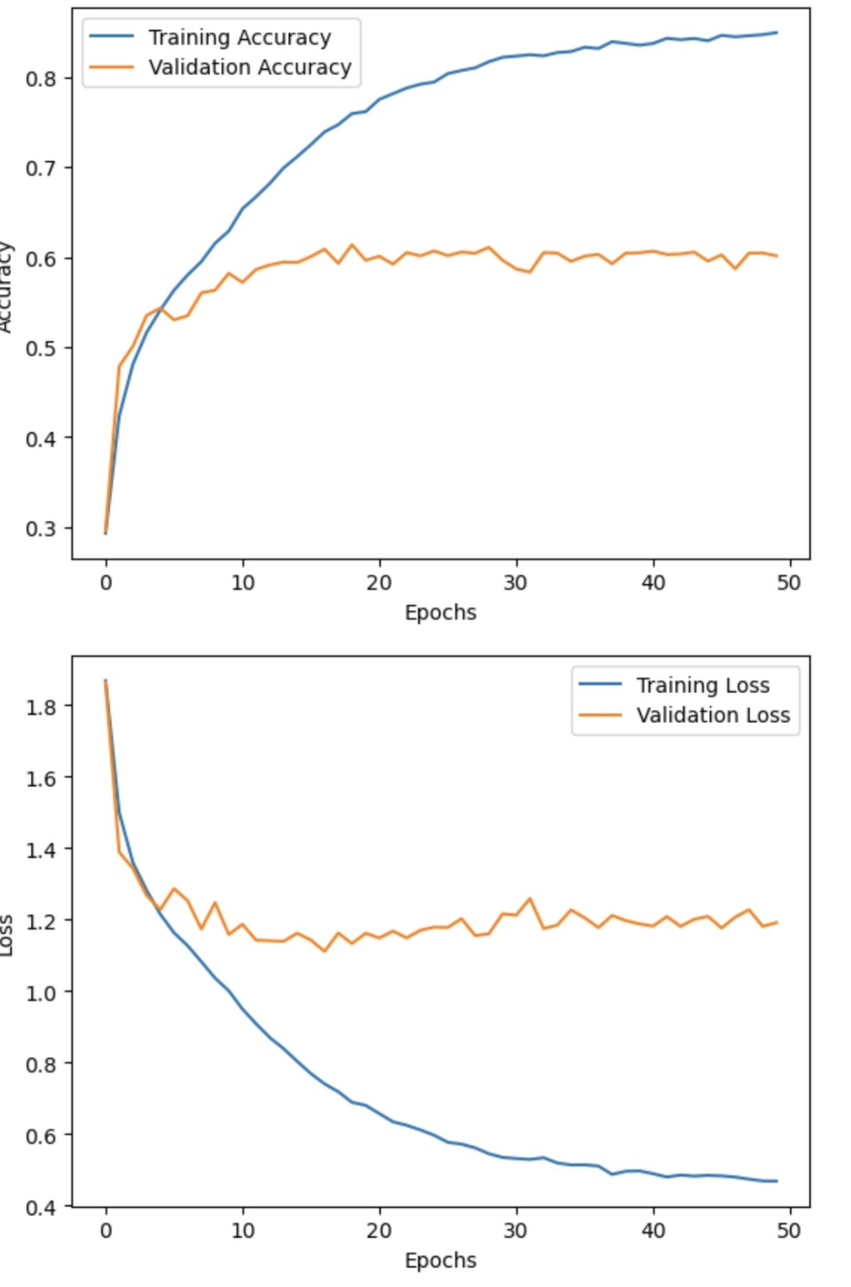

*Figure 7.2 Accuracy and Loss of Model*

### CHAPTER 7 RESULTS

**7.3 Comparison of different model accuracy**

| **Model** | **Accuracy** |
| --- | --- |
| CNN | ~64% |
| DenseNet201 | ~63% |
| DenseNet101 | ~41% |
| VGG16 | ~61% |
| VGG19 | ~62% |
| Resnet101 | ~47% |

*Table 7.2.1 Comparison of different model accuracy*

# CHAPTER: 8 SCREENSHOTS

### CHAPTER 8 SCREENSHOTS

**Sign-up Module:** Create a new account and join the platform.



**Login Module (OTP via mail):** Secure login functionality with OTP verification sent via email.



### CHAPTER 8 SCREENSHOTS

OTP in Mail



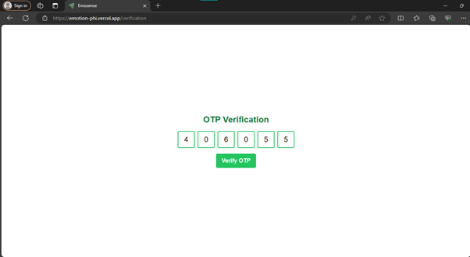

### CHAPTER 8 SCREENSHOTS

**Dashboard - Live Face Detection Interface:** Real-time face detection and emotion analysis dashboard.



Analysis Chart which shows all the emotion in percentage and also PIE chart.

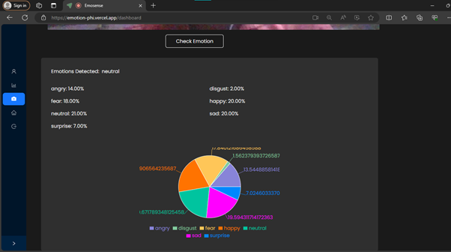

### CHAPTER 8 SCREENSHOTS

**User Profile:** Manage user information and preferences along with emotion history.

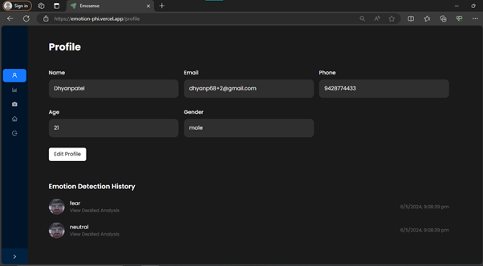

**File Upload Page for Emotion Detection:** Upload images for instant emotion analysis.

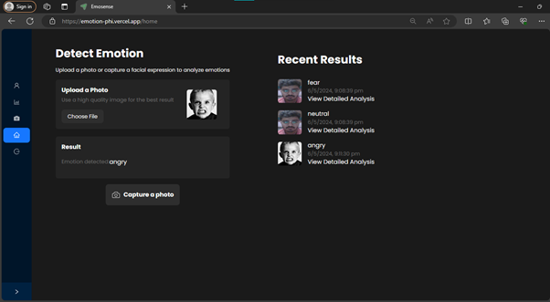

### CHAPTER 8 SCREENSHOTS

**Report Module:** Generate detailed reports on emotion analysis results.

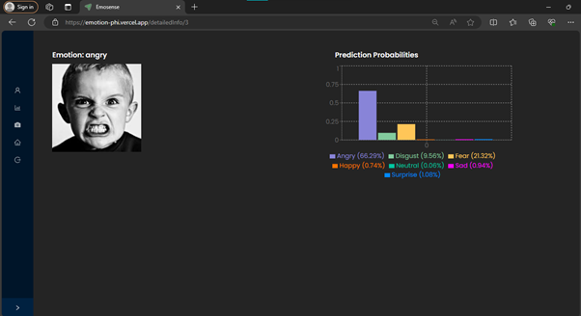

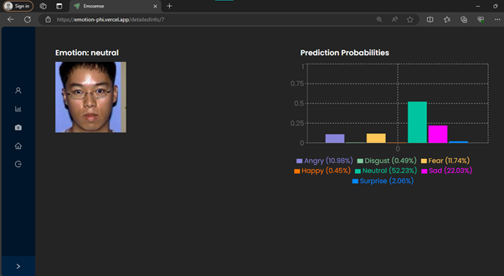

### CHAPTER 8 SCREENSHOTS

**Report Module:** Generate detailed reports on emotion analysis results.

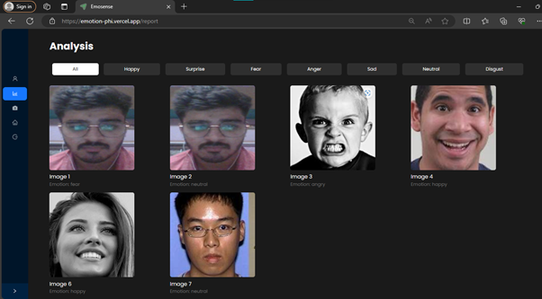

**Admin Module:** Access administrative functionalities and for user lookup.

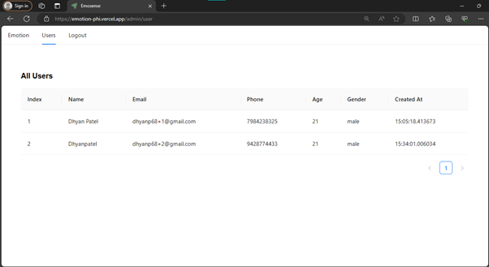

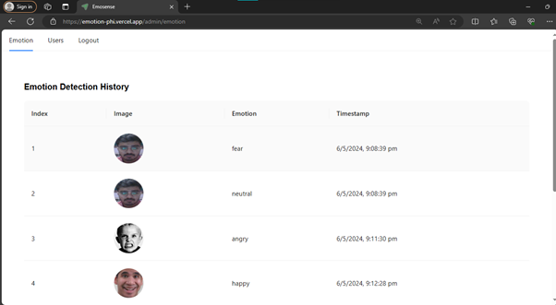

# CONCLUSION

In conclusion, the emotion detection system developed integrates various modules such as login with OTP via email, sign-up, a dashboard with live face detection capabilities, a report module, user profile management, and an admin module. Leveraging technologies like React for the frontend, Django for the backend API services, TensorFlow for machine learning models, and OpenCV for image processing, the system offers a comprehensive solution for real-time emotion analysis from uploaded images or live webcam feeds. Through continuous refinement and optimization, including addressing issues like overfitting and ensuring model compatibility, the system aims to provide accurate emotion predictions, contributing to applications in areas like mental health monitoring, user experience enhancement, and sentiment analysis in digital environments.

# 

# 

# 

# 

# 

# 

# REFERENCES

[1]A VGG Based Multimodal Facial Biometric System

[2]Facial Emotion Recognition and Classification Using the Convolutional Neural Network-10 (CNN-10).

[3]VGG-NetArchitectureExplained <https://medium.com/@siddheshb008/vgg-net-architecture-explained-71179310050f>

[4]DenseNet

<https://medium.com/nocoding-ai/densenet121-760df192f12d>

[5]Introduction to Convolution Neural Network

<https://www.geeksforgeeks.org/introduction-convolution-neural-network/>

[6]Convolutional Neural Networks (CNN) — Architecture Explained

<https://medium.com/@draj0718/convolutional-neural-networks-cnn-architectures-explained-716fb197b243>

# PLAGIARISM REPORT

